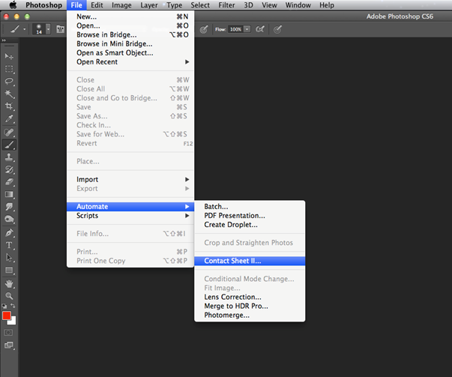
How to create a contact sheet in Photoshop

- Make sure your images are in a folder. Open Photoshop then click File >Automate > Contact Sheet as indicated below.

- The contact screen window will open, click on 'choose' and select your image folder on the desktop, you can select the number of columns and rows (5 by 6 is the default setting) you require and then select 'OK' to build the contact sheets.
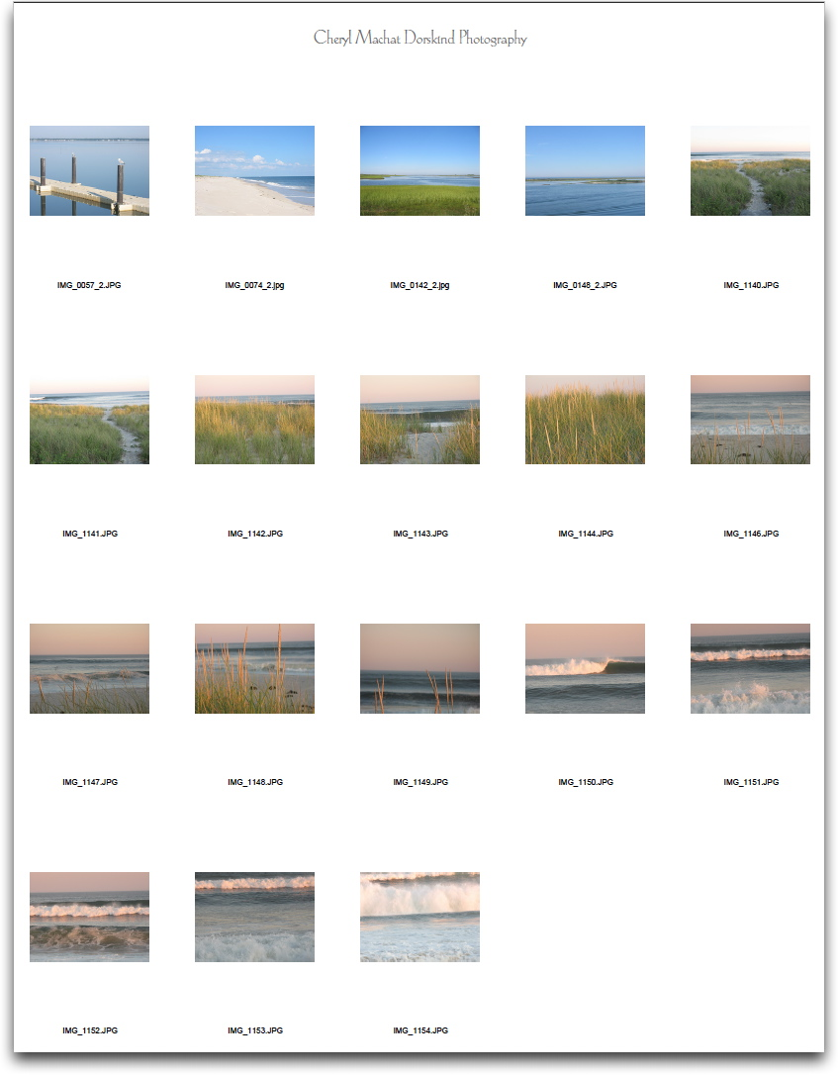

- If you have lots of photos photoshop will produce multiple contact sheets (you can see them as tabs) and must click on them to view each contact sheet
This is a tab

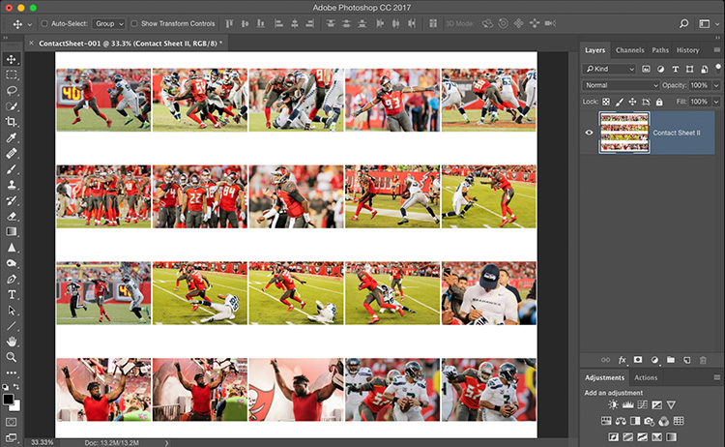

- You must now save each contact sheet as a JPEG – save to your memory stick or your SD card.
- Choose File > Save As...
- Select JPEG as the file format type for the image.
- Enter the desired file name in the Save As field. Click Save.
- Choose the Image Options for the JPEG, including image quality and Format Options. Click OK.

